Assignment: 11

Name: Swarnava Chakraborty

Roll no. 20 Dept.: CSE Year: 4th Date: 21-01-2021

1. **Create a webpage which will contain some message clicking on which the message will get changed to some other message.**

**<Code>**

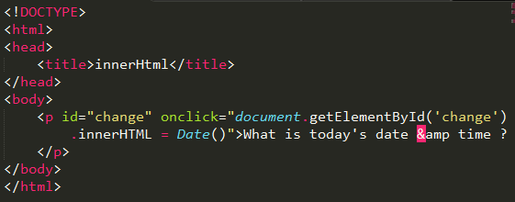

**Output:**

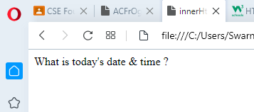

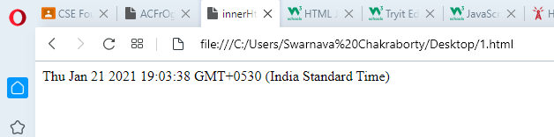

**2. Create a webpage that will contain some button which on clicking will display "Hello World !!!".**

**<Code>**

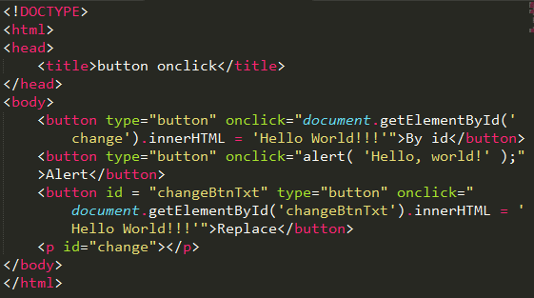

**Output:**

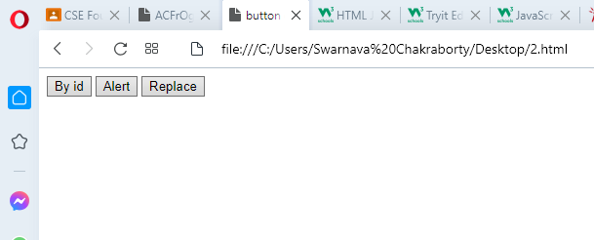

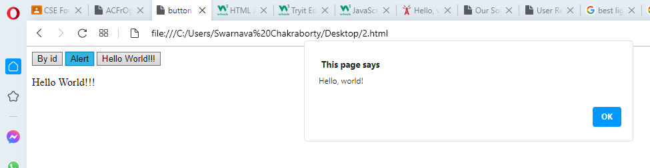

**3. Create a webpage that will contain a registration form with a submit button which on clicking will display a welcome message.**

**<Code>**

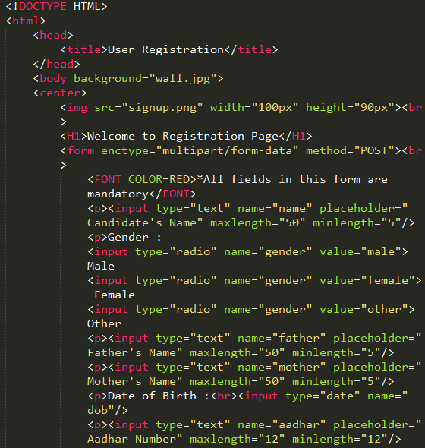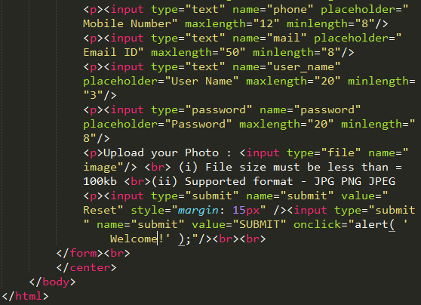

**Output:**

